**REPORT OF**

**LIQUID BRIDGES**

# **ABSTRACT**

We are start with the project of liquid bridges. First of all, we consider two plates which is sphere. As a parallel. A liquid bridge is created when a droplet is pinched between a single plate structure (SPS) and a parallel plate structure (PPS), which frequently happens in digital microfluidics. There are two surface creates two plate and forces between two shapes. Only capillary forces are available in the static state, but as the LB is stretched, the viscous force comes into play. enters the picture. As a result, the LB might be stretched. used to measure the viscosity of tiny liquid volumes. In An experimental setup is created for the current investigation to Stretch an LB created by the intersection of a flat and a sphere. Approximately one millimetre in radius, a liquid drop is suspended. between contact objects in motion. To extend the descent, the A linear actuator powered by a stepper motor regulates the displacement of one end. By measuring the cantilever's deflection using a bridge's force as a reference, optical fibre displacement sensor. In-depth research has been done on analytical and numerical solutions for nonlinear fluid bridge profiles under static conditions. Knowing both capillaries and viscous forces is necessary for the practical engineering design of micro-objects that include liquid bridge creation. When a load from outside causes a liquid bridge to elongate, capillary forces initially outweigh viscosity. However, the viscosity impact outweighs the capillary force at close proximity to the breakdown condition [6]. Specialists pay less attention to this investigation of the liquid bridge under elongation conditions since viscosity is such an important factor. Only a small number of scholars have provided modelling findings for dynamic loading circumstances, but these studies lack experimental evidence. By just measuring the diameter of the fluid bridge prior to its breakage and the amount of time needed to break it, several expertly crafted techniques for assessing viscous. We are focus more on calculation in liquid bridges. This is more important to this report. We can be verified in the experiment of viscous data. We can calculate in exact result between forces and velocity.

**CONTENTS**

**ABSTRACT** 2

**CHAPTER 1** 5

**INTRODUCTION** 5

**1.1 Types of liquid bridges** 8

**1.2 Definition of liquid bridges and geometry** 11

**1.3 Definition of porous media** 13

**CHAPTER 2** 14

**LITERATURE REVIEW** 14

**2.1 – Configurations of the liquid bridges** 14

**2.2 Liquid bridges analysis** 14

**2.3 Interaction stability and structure of liquid bridges** 16

**2.4 Liquids bridges of surface capillary** 16

**2.5 Differential equation of geometric partial** 17

**2.6 – Granulation** 19

**2.7- Non – particle of granulation wet** 21

**2.8 phase heat and mass transfer of surface tension** 23

**2.9 various process in the capillary bridges and phenomenon** 25

**2.10 The measuring of technique force** 26

**2.11 The zone of temperature distribution** 27

**2.12 Formation of liquid bridges** 29

**2.13 Liquid bridge volume** 30

**2.14 Criterion of liquid volume distribution** 30

**2.15 Calculation of force in liquid** **bridges** 31

**2.16 Rough surface between liquid bridge** 32

**2.17 Two sphere between liquid bridges** 32

**2.20 Graph of mobility porous** 33

**CHAPTER 3** 34

**3.1 Mathematical model** 34

**3.2. Force of liquid bridge between two plates** 34

**3.3 Sphere is equal between liquid bridge** 37

**3.4 Liquid bridges of non-parallel plates** 38

**3. 5 The surface of two planar between the capillary bridges** 40

**3.6 Two parallel plate in identical materials** 41

**3.7 Two parallel plate in same materials** 41

**3.8 liquid bridges of unsaturated porous** 42

**3.9 In the two-dimensional liquid bridge** 42

**3.10 Method of numerical** 47

**CHAPTER 4** 49

**EXPERIMENTAL AND RESULT** 49

**4.1 Perform force calculations for systems of increasing geometrical complexity** 51

**4.2 Result of simulation** 51

**4.3 Another method of Geometric model of derivative process** 52

**4.4 Capillary force calculation** 53

**4.5 Description method of experiment** 54

**4.6 Result of these two experiments** 55

**CONCLUSION** 57

**REFERENCES** 60

# **CHAPTER 1**

# **INTRODUCTION**

This is report of liquid bridges. It is the difference between absorption and distribution there are leads between soil and strength. There are several industrial procedures, such as liquids fluid atomization, knowing how viscosity effects of the fluids affect combining, storing, injections, and conveyance available among components to calculate the required forces to be used at different phases. A large number of these occurrences are impacted by the development of water bridge between the ground of the particles. Small volumes of water in biology to permit frogs, liquid bridges must be present. The mechanisms that allow scorpions, snakes, and invertebrates to move the experimental effort to measure the extensional viscosity of has utilised liquid bridge construction. nonnewtonian fluids. The nano-sized result is affected into high humidity and slowdown in the environment. It is the presence of the atomic forces. A fluid bridge forms when a little quantity of liquid is responsible for the presence surfaces that are close to one another. Whenever the space between objects is narrow enough, capillaries reactions can also create liquid bridges. In the literature, the liquid bridge is also known as the menisci, water bridge, or capillaries bridge. The reduction in surface tension led to the creation of this liquid footbridge. Depending on the kind of the surfaces among which the liquid bridges is generated, the profile of the liquid bridge is often formed as a convex, cylindrical, or coasters [5]. Such liquids bridges patterns are the consequence of the liquid's surface energy and the headers between both the fluid and surface. Concave liquid bridges are formed by two hydrophilic surfaces, curved liquids bridging by hydrophobic tail surfaces, and circular fluid bridges by two neutral surfaces. We will use the two-plate front to one another as put into the parallel. It is used in the tension of surface area. We use wo equation in numerical part first is LaPlace and second is bridges of MATLAB. In-depth research has been done on analytical and numerical solutions for nonlinear fluid bridge profiles under static conditions. Understanding both capillary and viscous forces is necessary for the practical engineering design of micro-objects that include liquid bridge creation. When a strain from outside causes a liquid bridge to elongate, liquids initially outweigh viscosity. However, the viscosity impact outweighs the capillary force at close proximity to the breakdown condition [6]. Experts pay less attention to this investigation of the liquid bridge under elongation conditions since viscosity is such an important factor. Only a small number of scholars have provided simulation results for dynamic loading circumstances, but these studies lack experimental evidence. Two plates that are hydrophilic make a curve, two materials that are hydrophobic form a curved surface, and two plates are neutral. We use two methods. According to what they found, the liquid bridges in the upper fractures become unstable much sooner than those in the lower fractures. According to the findings of gravity drainage in stacked blocks, an effective capillary continuity is maintained through the formed liquid bridges when the fracture aperture is less than a critical value. On the other hand, when it comes to thick fractures, the hanging drop inside the fracture is what controls the fracture capillary pressure, which is typically not very significant. The use of a glass micromodel that represents a stack of two blocks at different tilt angles is put to use in this research project to investigate the stability of liquid bridges in fractured porous media at the pore scale. They noticed that as the tilt angle increased, the stability of liquid bridges increased, but the frequency of liquid bridges decreased, leading to a lower total number of liquid bridges. They also reported that increasing the tilt angle results in a greater ultimate recovery of GOGD, but results in a lower recovery rate. This is the opposite of what was expected. They identified two distinct types of liquid bridges, which they referred to as the first type and the second type respectively. Because the first type of liquid bridge is formed when a liquid-saturated fracture is gradually encroached upon by gas, a GOGD process will only ever produce one instance of this type. While the second type of liquid bridge is formed when the liquid film thickens and reaches the upper face of the lower block, the first type of liquid bridge occurs naturally. The formation and breaking apart of bridges of the second type takes place multiple times throughout the GOGD process, and as a result, they are the primary contributor to capillary continuity. Researchers Deja et al. [18] investigated the process of liquid rein filtration into fractures between two porous matrix blocks as it occurs through the formation of liquid bridges. To find a numerical solution for the prediction of the depth and rate of the rein filtration, they utilised a generalised form of the Lucas–Washburn theory for a porous medium. This allowed them to make more accurate predictions. According to their findings, there is a beneficial effect of fracture capillary pressure on the phenomena of retarding rein filtration. They also demonstrated that the importance of inertial force is only present for a very brief period of time in the beginning stages of rein filtration. In the absence of gravity, a researcher presented a numerical solution to the YLE, which determines the interface profile of a liquid bridge between two parallel plates. They did not research the criteria for the stability of liquid bridges, nor did they investigate the relationship between capillary pressure and liquid bridge volume or liquid saturation. In order to investigate the stability of liquid bridges that exist between two horizontal plates, a researcher discovered a correlation between the net capillary force, the contact angle, and the volume of the liquid bridge. They created a map that displays three distinct regions, namely liquid bridge break-up, liquid bridge formation, and non-existence, by combining a range of values for contact angles with dimensionless liquid bridge volumes. This allowed them to display the three regions on a single map. A scientist used fine-grid numerical simulation to analyse the role of fracture capillary pressure models on oil recovery by GOGD. The scientist used several models, such as zero, constant, and three different saturation-dependent fracture capillary pressures. The results of the analysis were presented. Although a constant fracture capillary pressure or a saturation-dependent fracture capillary pressure improves ultimate recovery in comparison with zero capillary pressure, the amount of recovery enhancement depends on the model of capillary pressure. Zero capillary pressure does not improve ultimate recovery. The shape, stability condition, and capillary pressure of liquid bridges between two horizontal plates, which represent a horizontal smooth fracture, were obtained by a researcher with the help of the numerical solution of the YLE. They showed that there was a reasonable match between the computed interface profile and critical aperture of liquid bridges and some experimental measurements by comparing the two. The studies that were discussed earlier concentrated their attention primarily on the characteristics of liquid bridges in smooth fractures. On the other hand, the surface of natural fractures is typically rough. In a more recent piece of research, a scientist examined the stability of liquid bridges inside horizontal rough-walled fractures in addition to the capillary pressure exerted by those bridges. They discovered that an increase in the frequency of asperities on the fracture surfaces, as well as an increase in the size of those asperities, results in an improvement in capillary pressure and liquid bridge stability. In addition to this, they developed expressions for estimating the critical fracture aperture and the fracture capillary pressure as a function of the liquid saturation and the fracture geometrical properties. In spite of the theoretical or experimental efforts made to characterise the formed liquid bridges, the process of formation of a liquid bridge from a travelling liquid thread in real fractured porous media is still not well described. This is because a travelling liquid thread in real fractured porous media acts as a precursor to the formation of a liquid bridge. The phenomenon of drop formation in a falling stream of liquid has been the focus of research due to the numerous applications that can benefit from understanding it. The most common types of drop formation are fluid jetting and slow dripping, which both involve fluids. A jet is typically produced whenever fluid is forced out of a nozzle at a high velocity. However, the rates of liquid flow in fractured rocks underground are much too low for there to be any possibility of fluid jets. The flow of liquid in fractures, both vertical and horizontal, is analogous to a slow drip coming from a nozzle when gravity is present. If the flow rate is low enough, the role that flow plays in the system can be ignored, and a series of conditions that are in static equilibrium can be formed regardless of the flow itself. In the well-known pendant-drop method for the measurement of surface tension, this is the scenario that is taken into consideration. However, when considering the intermediate flow regimes, one must take into account the effect that flow has on the size and shape of the droplets.

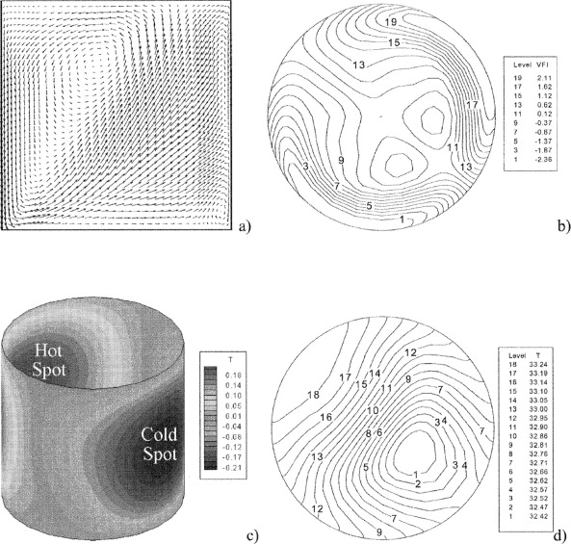

**Figure 1.1 Liquid Sphere** .

## **1.1 Types of liquid bridges**

**A -Liquid bridges of thermal convection** - Due to its highly association only with flying approach for crystal growth, the fluid bridge configuration has attracted a lot of attention. Due to changes in interfacial tension and density that are connected to temperature gradients in the bulk and free surface, correspondingly, both spontaneous and Marangoni flow develop in the polymer melt. Whenever the temperature difference between the solid rods is greater than a specific level, the simple isotropic flow that is created for low temperatures differs to a far more complicated movement. The emergence of lattice faults during crystal formation is thought to be caused by this supercritical flow pattern which drastically lowers the quality of the final product. One of the main reasons Marangoni convections in liquid bridges has been extensively explored both theoretically [24] and practically [25, 26] over the past few decades is because of this undesirable effect. The liquid bridges of intensity measurement in the dimensionless of Ra = sigma. delta l. where sigma is rule of surface tension between two parallel plates. There is distance between two density and kinematics velocity of thermal energy. Particle aggregation structures, for example, have been discovered as a result of research into this thermocapillary movement [31]. When certain conditions are met, particulates added to the liquid bridge don't behave like tracers; instead, they almost entirely separate and arrange themselves along closed spirals that rotate like solid bodies around the fluid bridge axis. The perception of this occurrence has caused some debate.

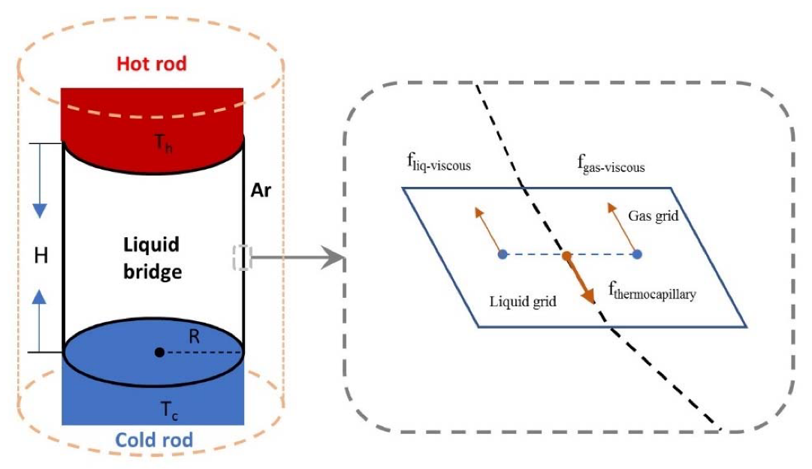

**Figure 1.2 Liquid bridge of hot rod**

This image is shown that single container inside the liquid bridges and connected to the hot rod to height h and connected to the parallel plates in the angle of 90 degree. There are four types of gas grid like liquid gas, thermos capability, liquid of forces and liquid of gases.

**B – liquid bridges of isothermal -** This can be joined in the iso thermal and here very hard shape to field of appearing in the small instruments and size of particle is very small. There are used in the three cases and these connect to two parallel this is space between parallel to each other. As soon as the liquid bridge links two flat solid surfaces, setup is significantly easier. Recently, there has been some interest in the transfer of liquid through the space between two non-parallel plates. A portion of the fluid drop's weight is transported from the giver side to the acceptor surface when it is wedged between two horizontal solid surfaces that are moving apart from one another. Critical ramifications for printing technology result from the liquid bridge’s semi or dynamic stretching and eventual breakage. One key function for small liquid bridges with touch lines travelling over equal spacing in pertinent micro technologies. This thorough grasp of fundamental fluid flow mechanisms is beneficial to all of the uses indicated above. Shifting touch lines provide a significant barrier to achieving such knowledge so there is still numerous big problems with their behaviour that have not been addressed. The treble contact lines' anchoring on the two supporting parallel plates, which solves the wetness issue, may be imposed on the fluid series connection to further simplify it and collect credible data. This decision offers significant benefits so from a theoretically and experimentally perspective. The triple contact line dynamics which form a difficult problem, particularly for rougher surfaces, need not be modelled at the conceptual level. Actually, the anchoring condition may be easily implemented in any interface-tracking numerical techniques since it simplifies to a simple equation for the interface position. Technologies involved in the creation and polishing of hard substrates is not used during experiments. Rather, a straightforward milling operation that creates jagged corners on the bearing discs guarantees that the connection lines are pinned to such surfaces. For practical production of such a fluid flow, nevertheless, poses significant practical challenges. These are accomplished in the current case by extending a nearly spherical fluid bridges in weightless that is only held together into interfacial tension. The disc widths' flexibility, which is expected to sustain optimal continuity equation, is a major problem. The ultimate results of this procedure are significantly poorer than those of the conventional method using fixed discs. Porex provides material knowledge in bonded fibre media in addition to porous plastic medium. Our manufacturing procedures use synthetic fibre bonding techniques to create components affordably and with a wide range of extrusion profile shapes. a combination of polymeric fibres linked with each other to create the best capillary architecture for handling fluids. Polypropylene, polypropylene ( pp, polyamide, cellulose, acetic, as well as other fibres are examples of substances.

In order to meet the needs for a large variety of liquid transmission design specifications for the medical, industrial, and consumer industries, Porex has vast expertise with many fibres different materials. On the basis of client requirements, the material is carefully chosen.

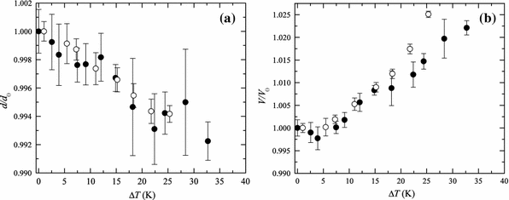

**Figure 1.3 Graph of temperature change**

This graph show that change the temperature between two parallel which low temperature in the gaping part. The difference between both graph is 1 and 5.

## **1.2 Definition of liquid bridges and geometry**

The distance between the two-contacting plate in the piece of separating distance d in the constant of liquid theta and half filling angle between the theta = 0. In the liquid bridge is only important to the plate of two parallel pieces. The bridge volume of dimensionless and the particle of low volume. We show you liquid bridge between two plates. The angle of these two surfaces in the capillary force that make a suitable for x axis and y axis in this field of channel in the same sphere of circle of distance r1 and r2 the velocity of l to b is same as the contact angle and gravity is zero of all particular time. We show forces equation and write equation of two radius. We can calculate the both circle forces in cross sectional area. The geometry part of regulator supply in the separation of d and change in pressure.

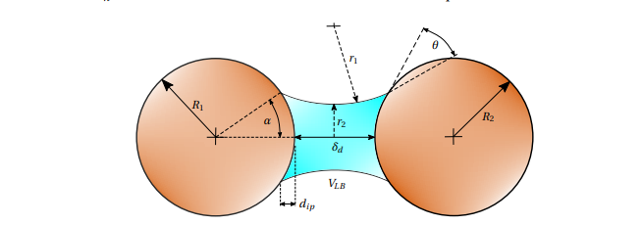

**Figure 1.4 Theory of capillary forces**

The channel capacity will take the form of a circular path with a radius of one, according to the Young-Laplace formula, which explains the differential pressure (the meridian radius). This will only be the situation if it is considered that the effects of gravity and the contact (wetting) angle are minimal. The liquid-cohesive bridge's pressure is the result of the addition of two pressures.

* **We write a formula of tension of force**

Ftension = 2*pi*r2 Gama

* **We write a formula of suction**

In the two circles are separated by distance d



The second is the force of resultant in the pressure of hydrostatic of change in p the suction force is the computed in the liquid bridges. As the component of suction pressure of cross-sectional area in the radius of r1 and radius of r2.



In both forces are separated in the normal direction



This expression is the calculated by the approx. force in the liquid bridges. The calculated in the maximum force to the minimum force. It is the separated particle in the difference between the volume and the numerical integration.

## **1.3 Definition of porous media**

It is a solid part of porous media in composed by body is called solid matrix. In the single-phase system According to), a phase is a physiologically homogenous section of the system under study that is physically divided from other sections of the same kind. A single fluid, such as water, or a combination of fluids fills the vacuum area of a diffusive in a single platform. a number of liquids are entirely miscible with one another (e. g. fresh water and salt water). The empty region in a flow regime is filled by two or more fluids that are incompatible with one another, keeping a clear separation between them. them (e. g. water and oil). Since hydrocarbons are only present in one gaseous phase consistently entirely miscible. formally the permeable format's hard substrate.

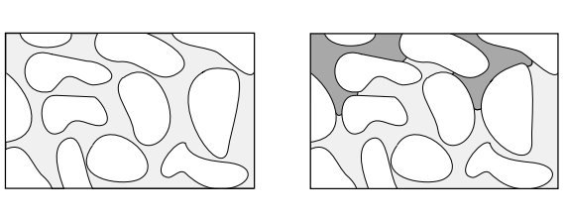

**Figure 1.5 Two hard Substrate**

* There are some restrictions of mathematical model in fluid flow of the porous media
* It is interconnected by space of porous media.

# **CHAPTER 2**

# **LITERATURE REVIEW**

## **2.1 – Configurations of the liquid bridges**

The configuration of the work is isothermal mass and its measure of volume v in the disk of distance l. Interfacial tension, fluidity, and volume of the liquid bridge are all equal to. Because the kinematic viscosity of the gas is far less than those of the liquid, they have no influence on the functioning of the fluid bridges. The triple contact lines are pinned to the edge of the discs as a result of the axial centrifugal pull acting on the liquid, which has a value of g per unit mass. Along with these additional parameters, we will also take into account the irregularity of the discs, lateral gravity force, electrical compels, shear modulus, and persistent surfactant during this whole examination. The l is the length of characteristics disk r. the length of mass m is defined as a = l/3r). in the capability of surface tension and it dominate the pressure of liquid there are dynamic viscosity. And its almost take a graviton Al force. In the milometer and its leads with stable liquid.

## **2.2 Liquid bridges analysis**

The capability of liquid bridges between the two plates and sphere it considers the presence of interaction between two plates and it led to be attractive and repulsive force but this force depend on the shape and size**.**

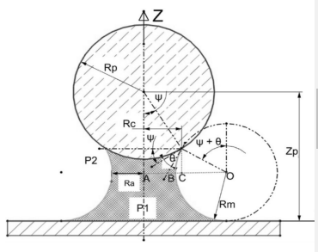

**Figure 2.1 Liquid bridges analysis**

The effective and repulsive and attractive force in the tension pressure and viscosity in formulation of



We consider the volume to be sufficiently small to ignore the gravitational influence. Additionally, it is presumable that the capillary force is determined under stable conditions. For the geometric study of capillary force, it is assumed that liquid bridges have a circular contour and rotational symmetry. Let we consider the bridges of liquid in the counter and rotational circular symmetric. The liquid profile in the sild surface in the subject of force of surface tension. Then we can compute the accumulator in the bridge of inside liquid. At the interface, the Laplace pressure operates in the normal direction on the projected cross-sectional area of the liquid bridge. Capillary force affects both in Laplace and surface tension.



H stands for the liquid contact angle, W for the half filling angle, and Rc for the radius of the sphere that is in contact with the liquid. Surface tension affects the capillary pressure Pc as well as the azimuthal radius and the meridional radius Rm Ra, the cross-sectional radius with the smallest the liquid span Capillary pressure-related force.



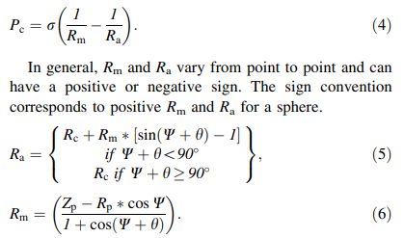

The surface tension of stretch liquid in the addition of viscous force will be added then higher rate is due to very small and force of viscous is neglected.

## **2.3 Interaction stability and structure of liquid bridges**

Researchers see the slim approach performs superbly in the instance of a liquid bridge rupturing in air near to the singularities. Its scenario where a liquids bridges of one liquid bursting although being surrounding by some other fluid that is immiscible with the first will now receive our attention. The lava lamp is a really lovely and well-known example of this technique. A lighter fluid is gradually rising throughout a denser, very flowing liquid in the experiment (or lava lamp). The rising lighter fluid bubble eventually becomes so far off from the main body that a neck forms, which is ultimately burst by tidal forces. They demonstrate that stable answers that really are precisely self-similar (in space) may be found while maintaining the conical shape and accounting for both differential equations factors. Unfortunately, i give up the dynamic description of the interface provided by the Stark flow in our research for static answers of such.

## **2.4 Liquids bridges of surface capillary**

The liquid bridges between two plates in the boundary condition is forming in liquid bridges under the capability of contact angles y1 and y2 in given plates. The parallel of account in the effect of disturbance then it subject to considerable in the demonstration into the change of discontinuity change of spherical plates. In the particular they demonstration of that change in the drop of initially of spherical form. It depending on the spherical form. It depending on the specific data but it is also possible that titling may cause in the insider field of the vanish wedge of infinity.

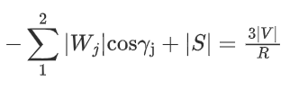

We show equation of liquid bridges of surface capillary were

S = free surface of spherical interface

V = volume of enclosed surface

R = radius pf surface area

We will use the result of two wedges in the two surface and its smaller than the mechanical energy and it’s connected to the liquid and its conformation in the same volume and its drop to the single face as well as no face volume it is expected in the mass and liquid.

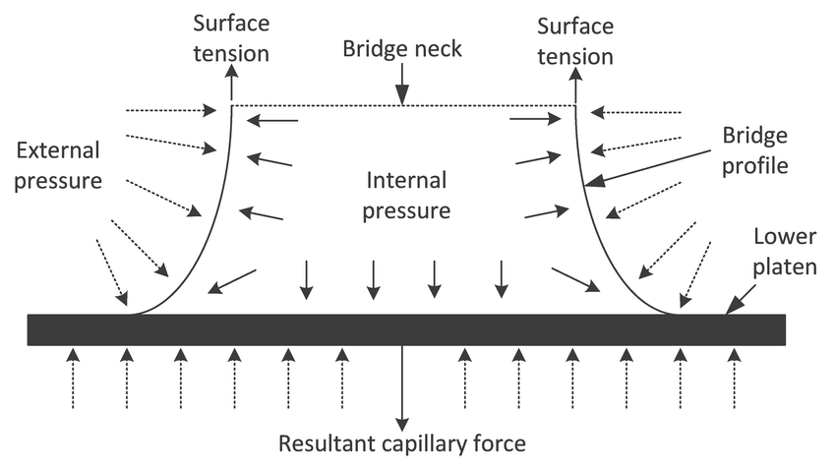

**Figure 2.2 surface capillary of liquid bridges.**

## **2.5 Differential equation of geometric partial**

The field of linear flow in the measure of deformation in the fluid viscosity and its deformation in the sample and component in the view of rheological tests and demands it distributed in the characterized of space and time.

Formula of geometrical equation

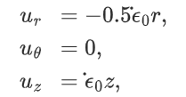

The formula of cylindrical coordinate system are given by ( r,theta,z) this is the flow of u and rate of e-not . the value of length and l not is given y radius r not for the specific value.

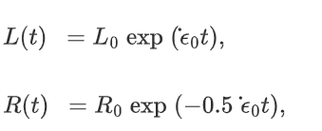

The value of equation is defined by the l(t) is the length of equation of t and the liquid of particular volume in the shape of all times. A practical production of such a flowing fluid, though, poses significant practical challenges. These are accomplished with in current case via extending on nearly spherical fluid bridges in space that is only held together via surface energy. Its disc widths' flexibility, which is expected to sustain optimal continuity equation, is a major problem. The ultimate results of this procedure are significantly poorer than those of standard approach using fixed discs. At Bremen's fall structure, the stretch of the fluid bridge was done successfully while in gravity. Extending required a space atmosphere in order to reduce fluid flow constraints. In this project we use in the Berman experiment. We will show you the image of Berman experiment.

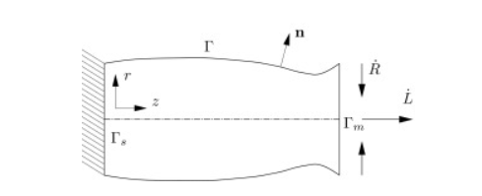

**Figure 2.3 Berman experiment**

The perfect accretionary flows is not entirely possible even under weightless (g) circumstances, despite adjusting the disc diameters; this is because the bridge contour is deformed by the fluid differential pressure, which is brought on by acceleration and capillary forces, according to Berg et al (1999). Instead, the surface and persistence forces can cause the true stretched liquid bridge to distort and finally pinch off in the plane of both the accelerating supports. This study aims to analyse this behaviour with regard to the flow parameters We (Weber number) and Ca = We/Re (capillary number) in order to identify the zones with more favourable fluid properties. To do this, we first investigate bending using analytical and simulation methods. When the numerical findings and experimental data are compared, they show excellent agreement. The behaviour of liquid bridges is then investigated using the technique across a significant range of Ca and We variables. In this topic we explain a numerical method this is the form of a free capillary in the mantle liquid bridge.

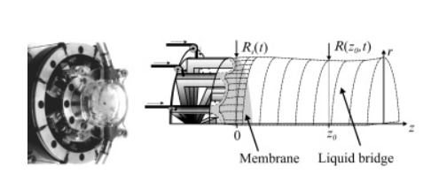

**Figure 2.4 Membrane of liquid bridge**

This image is shown that liquid bridge and the membrane of r(t) and r(z, t ) displays the outcomes of a typical experimental run with castor oil as an instance. The fluid bridge, which is kept between the membranes in microgravity, is shown in Picture (A) even before begins to extend. Two liquid emulsified drops are put within the bridge, which is almost cylindrical before bending, in order to study how they deform in this specific circumstance of accretionary circulation.

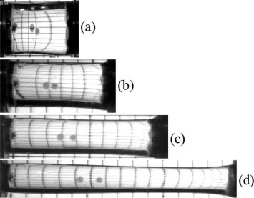

**Figure 2.5 cylindrical bending**

## **2.6 – Granulation**

First of all, we explain the granulation of the particle When it comes to WC-Co grading powdered, grinding is the process of creating grains of the ideal size for their ensuing crushing. Both a high workability and a low total porosity are required for the grains. When a bed of solid particles travels while simultaneously mixing in the presence of a melted organic binder, such as paraffin wax, the procedure is referred as granular. When the individual particles merge and bond together, this action produces subatomic particles. In the cermet sector, exfoliation in roller drums is a frequently utilised process; in this instance, the granulation results from collisions of WC/Co grains and agglomerates in a bed of molten wax exposed to continuous movement. The rolling drum is arguably the most basic continuous grinding equipment. Granules could be utilised for additional processing, such as crushing green items, and have a markedly better ability to flow when compared to powders. Regarding both the strength of the granules and problems in its manufacture, it is critical to comprehend the phenomenon of the particles' adherence. The development of biological binding bonds between the WC/Co powder is the primary driving factor behind the agglomeration (granulation from fines) of cemented carbide powders. The granules are stabilised while chilling to ambient temperature by the melted plastic, which acts as a liquid bridge between them. The surface roughness of the particles has a significant impact on how well they adhere. The creation of an attractive force occurs when the singly or partly aggregated nanoparticles are moved against its Regarding the several carbide cutting grades that may be granular, versatility is the constructed granulation mankind's most significant advantage. Before the carbide grade is changed, the granulation units must be carefully cleaned. This process only takes 20 minutes. The workforce of multiple commercial drum granulation units is made possible by the low cost of these units. Each of these units is used to granulate one type of tungsten carbide according to the WC actually imply grain size, removing the possibility of pass between granules of various abrasive grade levels. Since the granulation drums are often open when utilising the new built method, dust dispersion is a significant hazard. The risk of uncontrolled WC/Co dust emissions must be reduced by using appropriate dust exhausting devices. As a result, the liquid bridge volume is determined by adding the total liquid film volume present in all of the particles and the fluid bridge percentage. When particles collide with a barrier, only the connecting component has a liquid film, hence the volume of the liquid bridge is equal to the fluid layer of the striking particle multiplied by the liquid bridge percentage.

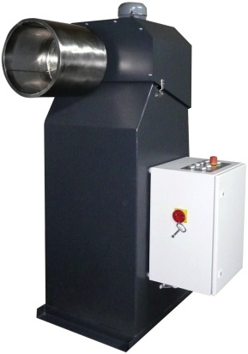

**Figure 2.6 granulation**

## **2.7- Non – particle of granulation wet**

Wet granulation was used to modify the physical characteristics of nano-particles. Through a bipolar tip, a 5 percent aqueous solution of hydroxypropyl cellulose (HPC-L) was sprayed over nanoparticles TiO2 particles. The minimum fluidization air velocity was established at a fluid flow air speed that really was around 1.5 times as high. Under binder content feeding rates, Figure 5 shows the time variation in the mass median diameter of the granules. The bulk average size steadily grew during the course of the conflict, and the rate of growth was faster when the binder feed speed was high. This suggested that liquid bridges produced by sprayed binder mist helped to facilitate the binding among nanoscale. The minimum fluidization air velocity was established at a fluid flow air speed that was around 1.5 times as high. Under different binder feed speeds, Figure 5 shows the time variation in the mass median diameter of the granules. The mass average size steadily grew during the course of the operation, and the rate of growth was faster when the binder feed speed was high. This suggested that liquid bridges produced by sprayed binder mist helped to facilitate the binding between nanoparticles. The tapping density of nanomaterials also rose with operating time, showing that agglomeration had considerably enhanced the volume of the nanoscale. The full form of SEM is that scanning electron microscopy.

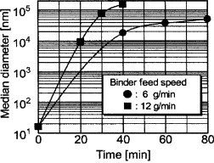

**Figure 2.7 graph of median diameter**

This is a graph of diameter of median verses time. In the case of same different time is feed speed is 6 gm/min. and second graph is show that density of trapped vs time graph minute. The location of point in the graph between the feed speed in the difference of 0 to 0.2 and 0.2 to 0.4 and 0.4 to 0.6 and 0.6 to 0.8 is the difference of binder speed.

And the time difference is 0 to 20 and 20 to 40 and 40 to 60 and 60 to 80 this all are difference of 20. It is a basic difference is like regulation system. The difference of graph is binding in the difference of the 10 as median diameter verse time. The angle between the feed speed is depend on the time flow this is very important to power supply. The line of graph is go to the power of 10 into 1. When the black circle shows that 9 gram per min and black square sows that 12 gram per minute. The origin of zero is due to the angle is 90 degrees. This is a diameter of the graph is min. to mix. The range of power is to maintain in to the regulation system.

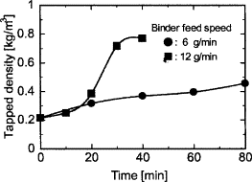

**Figure 2.8 Graph of tapped density**

## **2.8 phase heat and mass transfer of surface tension**

**a- Flow of liquid column** - In light of the aforementioned debate, it's noteworthy to note that we were unable to validate the oscillatory flow in a three-dimensional computer model of a flowing fluid as described by a number of papers. Even though it is explored in the physical process of oscillatory other writers are planning more theoretical and analytical investigations on space missions. Comes from the process flow in cylinder-shaped flying regions has been investigated as an analytical and empirical model for crystalline formation geometries in space as well as on Land. In both tests and numerical analyses, the crucial Marangoni number Mac for the beginning of vibration in fluid bridging varies greatly from 100 Mac 1.6 104. We are show a figure to vertical in the column of isothermal and condition of non – slip that both walls and isothermal work on lateral entry.

* The ratio of liquid is that H/D = 2
* Where D is a diameter of cylinder zone.

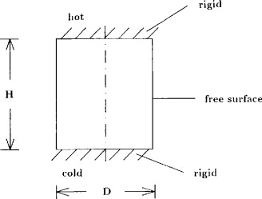

**Figure 2.9 liquid column flow**

This image is show in five outputs in the case of height and diameter where H is distance between two surface and D is a diameter of surface.

* Hot
* Rigid
* Free surface

In the 2-dimensional figure in the During weightless (a 0), pure comes from the process convective creates a two - dimensional, axially symmetric donut shaped vortex, whereas buoyancy convection alone (a = g) results in a quasi, three - dimensional (3d single roll. A superposition of two types of flow means three-dimensional pressure and temperature fields when the simulation's gravitation level is changed. Only a few elements of such research may be shown due to logistical constraints. In the surface of all particle in distortion part of these fluid in the case of complete part Our production methods utilize synthetic fibre binding processes to produce parts cost-effectively and with a wide assortment of extruded profile geometries. A blend of polymeric fibers bonded together for ideal fluid handling capillary structures. Materials include polyester, polyolefins, nylon, cellulosic, acetate and other fibers.

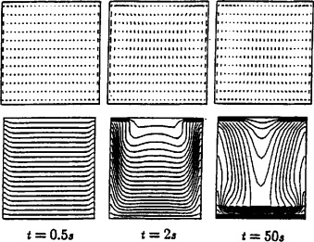

**Figure 2.10 2-d surface**

Is along airfoiled, a classic S-shaped heat transfer emerges. The temperature gradients are greatly decreased within a range of approximately 10% from the bottom and top; as a result, only tiny gradients are present in the middle of the column, at an altitude of almost 80%.

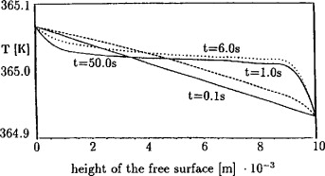

**Figure 2.11 free surface tension**

## **2.9 various process in the capillary bridges and phenomenon**

The experimentally They proved that there was little stickiness in clear, low humidity. Nevertheless, a noticeable adherence was seen in moist climates, especially with hydrophilic glass surfaces. The adherence at saturation moisture was identical to what would be seen if a single fluid were to be inserted here between sides and Stone prior practical tests produced results that were comparable. Due to the reduced pressure inside the liquid bridge and the direct action of the surface tension force exerted around the annulus of the comma, the production of a liquid link between two flat objects can result in the development of an attracting attraction across them. We must state right once that, under such circumstances.

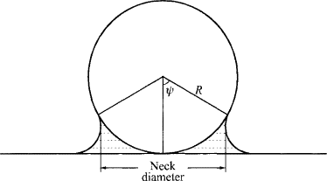

**Figure 2.12 flat surface**

There are many practical systems in the recognize of experimental of capillary bridges. There are many types of moist of porous media in the dispersion of powder in the liquid phase. The action of the filed bridge in the fluid phases is the importance of the surface.

Bridges are drop oil between two scenarios of film like

A – Create a film of rupture of rewetting in the ones drop.

B - The oil bridge may be configured in an insecure manner, and material fracturing may occur in the growing centre of the destabilised bridge. This last process was seen experimentally using a high-speed video camera and the findings were explained using the blood capillaries instability hypothesis.

## **2.10 The measuring of technique force**

* Instability of mechanical - the most prevalent kind of instability, which is caused by a force of attraction who’s gradient dF/dD is greater than the stiffness K of the springs holding the surfaces together (or, more correctly, the overall stiffness of the whole instrument with the loading points defined by the two surfaces). On approach and detachment, respectively, there is an instability for the straightforward force-distance curve seen in Figure 12.3a. Dynamical instability are those that depends on the force acting between both the two plates. A liquid bridge between two surfaces that can break creates a physical volatility known as a Lorenz volatility, which leads to destabilisation in the capillarity. It can be demonstrated (see Section 17.11) that the bridges gets fragile and disintegrates into one or two cone - shaped raindrops or glasses when the sides are split by a specific distance indicated by Dc d (4V)1/3, at which point the force between the two surfaces rapidly decreases to zero. When measuring forces to establish the equilibrium (thermodynamic) interaction possibilities, which should ideally be recorded under "ergodic" or "quasi-static" conditions—that is, endlessly slowly—mechanical instabilities create issues. But regardless of how gradually two bodies are brought together or separated, a sudden jump will happen at a point that can't be prevented.

## **2.11 The zone of temperature distribution**

Coordination between tugging maximum growth rate is necessary because supercooling on the crystallisation front controls rate of growth. outlines some typical issues that arise with expansion and offers solutions. These really are simply recommendations since every substance, even ones that belong to the same family of chemicals, is different. Too little growth (lower supercooling, resulting from heating), lengthens the fluid bridges in the fall of supercooling. When development is too rapid (high supercooling, often when the zone is not hot enough), the crystallisation front becomes unstable, lowering the crystal quality. Furthermore, these circumstances may cause the gap between the rods to narrow. A crucial characteristic that must be put on the spot is the heat variation at the crystallisation front. The highest temperature in an area and heat variations are directly controlled by adjusting the output power of the lights, although the consequences of the modifications are delayed and the driver's preventive actions are, in general, fairly obvious. When isolated fluid components are compared to their continuous sheet flowing counterparts, there is a significant difference in the quick travel velocities and greater lengths that they can cover. In proper waste plans and assessments for groundwater, the effects of these kind of modes that have the capacity to concentrate diffuse liquid films into swiftly moving discontinuous liquids spans should be taken account. When addressing a community of fluid bridging inside a fault surface and mass buildup at fracture junctions, these stream concentrating mechanisms may well be intensified. The findings offer a practical framework for addressing and maybe measuring complicated and interrupted fluid flow seen in field and lab research. limitations relating to interactions inside fractures, inner break morphology and surface qualities, as well as other constraints. As a result, the liquid bridge volume is determined by adding the total liquid film volume present in all of the particles and the fluid bridge percentage. When particles collide with a barrier, only the connecting component has a liquid film, hence the volume of the liquid bridge is equal to the fluid layer of the striking particle multiplied by the liquid bridge percentage

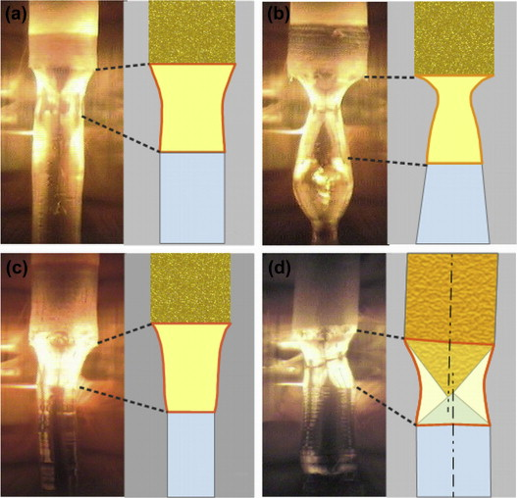

**Figure 2.13 zone of temperature**

This figure is shown by growth system of transport of heat. In the molten state energy is deliver by molten state but this temperature depending on the intensity of light. in the filament of tungsten of liquid crystal of halogen lamp like 1-2 micro wavelength. We add a heat this is lost by conductance of rocks and the surface gas. heat is lost by the conductance of rocks and the ambient gas. The heat transfer and spectral characteristics of the melting and crystals, as well as—to a lesser extent—the ceramics feed rod—determine the temperature distribution in the liquid bridge and the developing crystal. The Streak plate expansion had a well significant changes in the heat transfer after doping Y3Al5O12 with Nd, which has a significant absorbance peak in the representing approximately (NIR) area. Real patterns are shown in the OFZ studies. Merely a few people have tried to evaluate the interface geometry, heat, and fluid flow within the oxide melting zone, despite the intense modelling effort put into the silica development cycle. Although with the modest volume of the liquid zone (usually 0.4 cm3), extremely strong temperature gradients result in rapid convective flows. The results of Lan's modelling point to a flow speed of only a few cm/s in the region. The measured results of material parameters including interfacial tension, hydration angles, melt viscous, and bulk modulus, as well as emissivity factor and heat capacity of the molten and of the crystals, are needed to do focused modelling. Understanding how these attributes fluctuate with heat will help us get a full idea of the process. Owing to the difficulty of conducting experiments at the necessary extreme temps, most oxides have not yet had these characteristics quantified.

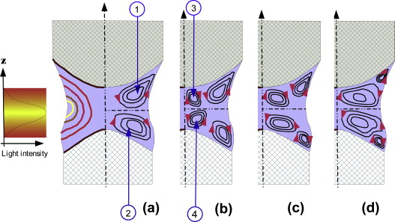

**Figure 2.14 Intensity telegraph**

## **2.12 Formation of liquid bridges**

The process of liquid bridges in the solid of mass in another boundary method in top left and left right this is pair before the contact. The liquid film volume that each particle possessed before to contact is smaller than the water bridging size. The liquid bridge force is a function of the liquid bridge volume and separation length, and it is preserved while the separation distance between particles is less than the critical separating value. When the critical separation distance is reached, the fluid bridge breaks (bottom right). In the event of a particle-particle collision, the liquid bridge volume is uniformly distributed amongst the colliding particles once it ruptures, and the liquid bridge force dissipates (in case of a particle-boundary collision).

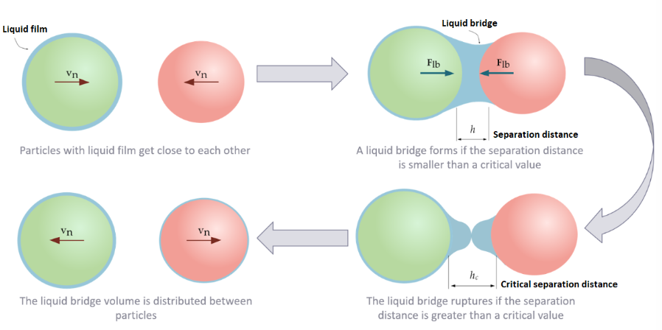

**Figure 2.15 liquid bridge formation**

## **2.13 Liquid bridge volume**

The user-inputted bridge mass flow rate, fb, specifies the portion of the particle fluid film content that contributes to the bridge's development. As a result, the liquid bridge volume is determined by adding the total liquid film volume present in all of the particles and the fluid bridge percentage. When particles collide with a barrier, only the connecting component has a liquid film, hence the volume of the liquid bridge is equal to the fluid layer of the striking particle multiplied by the liquid bridge percentage.

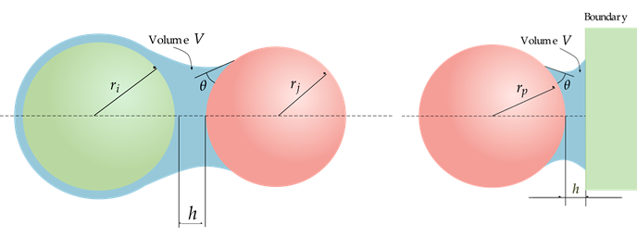

**Figure 2.16 volume of liquid bridge**

This is the volume of liquid bridges then it makes a collision between and separation between velocity of particle.

## **2.14 Criterion of liquid volume distribution**

The distance is computed between the regression of numerical solution of young Laplace equation. Distance of critical rupture hc us the volume of liquid bridges. The contact angle of involved particles

In the image of the particle of liquid bridges in the evenly between the rupture event. Of particle of different mass before Collison.

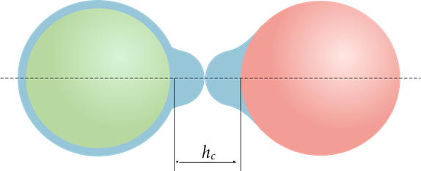

**Figure 2.17 distance h of liquid bridge**

**2.15 Calculation of force in liquid** **bridges**

The liquid forces is a capillary force Fc in the viscous force F**µ**

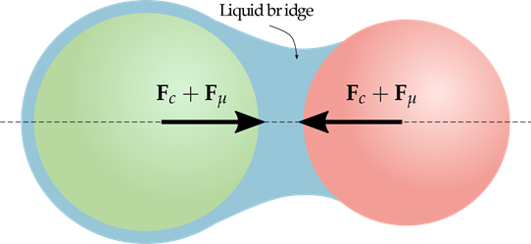

**Figure 2.18 force of liquid bridge**

According to the model capillary force is the basic pair of the bridge volume in separation between the angle of surface tension. In the user input tracked between the last two user input

* **We will use in the calculation of force during liquid bridges are**

Viscous force is explained through numerical theory it is normal tangential components is relative velocity and the fluid velocity. It is separation between the viscous force and its decrease. The user-inputted bridging mass flow rate, fb, specifies the portion of the particles fluid film content that contributes to the structure's development. As a result, the liquid bridge volume is determined by adding the total fluid film volumes present in all of the particles and the fluid bridge percentage. When molecules collide with a barrier, only the connecting component has a fluid flow, hence the volume of the liquids bridge is equal to the fluid layer of the striking molecule divided either by liquids bridge percentage.

## **2.16 Rough surface between liquid bridge**

As leaf tissue, water droplets are roughly spherical and readily roll off, washing the process surfaces. The Flower impact is the common name for this phenomenon. The essential components for these uses are a liquid drop with a wide interfacial tension (i.e., one that is extremely hydrophobic) as well as a shot's ease of movement or ability to roll off a hard texture (low hysteresis). Many A breakthrough study of the relationship between contact angle and waviness reveals that researchers come into consideration surface roughness by including a solitary asperity. It is obvious that increased surface irregularity lowers contact angle. However, studied the impact of diversity and energy dissipation in particular. They discovered that layer thickness only had a minor. addressed how surface quality affects, the fluid structure's thickness, interfacial tension, and viscous when one forms across a plates and a spherical.

## **2.17 Two sphere between liquid bridges**

These stresses imposed by a liquid link between the two hemispheres, a sphere and a plate, or a particle and a wall has been investigated first in and then expanded to encompass small circular bridging among particle sizes. among various substrates. presented a method for approximating toroid’s to by taking the angle into account, estimate the capillaries connection between two similar spheres. a formula for calculating the capillary force between Using the equations for the capillarity between a spherical and a plate, two spheres. analyses of Beginning with the, moving particles and the related liquid bridge creation were performed. The tests were put up by him to gauge the capillaries pressure and the when a frictional force once two waves travel at varying speeds, there is a sticky pressure, and the test data match nicely. A novel recrystallization model of binary collision between two identical wet particles is proposed only with equation, taking into account the forces exerted by capillaries and viscosity forces. by the curved arches. A technique for determining the capillary diameter was created by the capillaries force and presented a closed-form approximation to make the calculation more practical. energy amongst realms that are equal and unequal. the fluid bridges across round and tiny pendula's capillary force-separation properties. bodies. A scale technique was developed to create more precise nearer statements for the pressures for a specific bridging capacity and interfacial adhesion as a proportion of spacing.

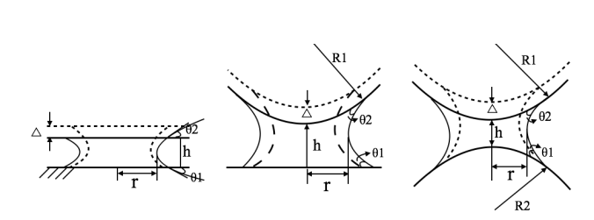

**Figure 2.19 closed form of fluid liquid**

**2.20 Graph of mobility porous**

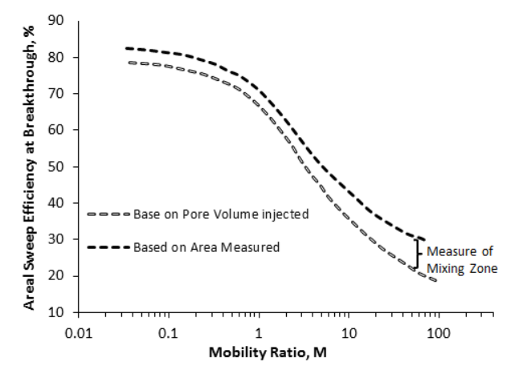

# **CHAPTER 3**

**METHODOLOGY**

## **3.1 Mathematical model**

In this chapter we use in calculation of mathematical model. We are implemented in numerical methods and to find the different methods like including sphere. curvature mean and pressure of capillary. We are calculated in the difference of two plates and two sphere .and these to be consider. This is the solution in the presence of gravity. Consider and modify the flat plate between two plates through absence of gravity. In the two sphere liquid bridges in the horizontal sphere.

## **3.2. Force of liquid bridge between two plates**

Let two parallel plates in liquid bridges

C is separation between distance d

Theta is an angle of contact

Alpha is half filling angle

R = sphere radius

The upper matrix block in lower face and the lower matrix block in upper face and it is smooth to the depicted in image 1. we stimulate between fracture of horizontal. The mean of curvature of surface tension it relates to young Laplace equation the surface energy evolved in the liquid bridge is the correspondence in the minimum surface of interest.

Yle is expressed to follow

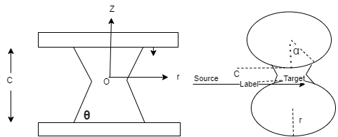

**Figure 3.1 liquid force between two plate**

The liquid bridge between the smooth plate in two equal spheres. It is the distance as the fracture in the theta contact angle

The formula of parallel liquid bridges between two plates are

Qc = σ [1/R1 + 1/R2]

Where pc = pressure difference

Qc = pg = pg-p σ it stands the tension of surface

R1 and R2 is the difference of the curvatures. We are expression is defined as the liquid bridges

Derivation of liquid bridges between in the two parallel

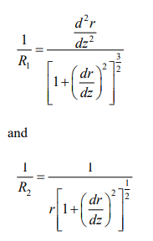  
in the liquid bridges in the curvature in the athematic in the average principal of radii this is the relationship between pressure difference by mean and curvature

QC = 2 σ h

We will describe with the two plates between the bridges

r Z = C/2=QC

Dr/dZ z = b/2 = cot(theta)

In the liquid bridges we contact with the boundary condition in the process of their equivalent part

We can substitute the second order differential equation in the numerical solution that make the equation in computational procedure we use in Euler method and the solution on the process of mean curvature in the vertical section as the liquid bridges as to obtain in the approximately in directly to the profile as follow.

V =

In the pressure difference between the mean curvature of uniform at any point at the field of neglected bridges as well as gravity influence of the ratio of tension force at the sufficient of small surface tension. It is defined the equation of liquid bridge.in the basis of force of gravity in the bond number is minimum.

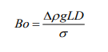

Were

Delta p = it is the difference between the liquid and surrounding gas

L – vertical length

If the influence of surface tension of gravity is very small when ratio is neglected in the gravity. The surface tension of liquid bridges then effect of gravity is measure.



Were

Δρ = difference between liquid and surrounding gas

L = vertical length

D= radius of characteristic radius

The equation of behaviour of solid particular are

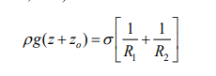

Were,

P0 = ρgz0 this is a difference of reference point and it is lower point of plate. The interface pf fracture along the pressure difference. This equation leads to the conclusion that when gravity is taken into account, pressure differential and interface mean curvature change over the length of the structure. Additionally, it is evident that as the break progresses higher, fracture the highest fracture capillary pressure occurs at the top end of when capillary pressure rises. bridge, the lower part of the top matrix block. Because the liquid bridge when there is gravity Equation 8 could not be applied as a boundary condition because force is not equal about the r-axis. As a result, only the solid contact point is specified for Equation 11's boundary conditions. solving YLE in Equation 11's inclusion of gravity, together with its associated initial conditions and constant replacement approach is employed. This approach uses second derivative quasi

## **3.3 Sphere is equal between liquid bridge**

We are solving the YLE method between two plate the boundary condition specifies by the liquid bridge. Therefore, the choice of neck radius or contacting radius will determine the critical fracturing opening (or critical spacing) for this system. If a liquids bridge is assumed to exist between two entities with a very modest liquids bridging volume compared to the volume of the solid spheres, the liquid bridge will resemble a bridge between two plates. We are find to solve numerical method it is form of analysis of dimensional form. Additionally, the YLE nondimensional analysis for the scenario of a liquid bridge between spherical is more logical. As a result, by taking into account a liquid bridge between two spheres, several characteristics of liquid bridge in horizontally cracks are explored. The specification of dimensionless variables results in some reduction of the numerical approach for a liquid link between two identical spheres.

The formula of rD and zD is

rD =

ZD =

the coordinate of dimensional is written as

HD =

we put the all value in given equation

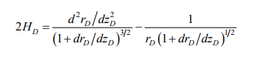

We solve the equation and found to be radius in the liquid bridge. In the boundary condition of radius is in liquid bridges.

rD zd = c/2r = sin (α)

drD/dzd zd=c/2R = cot (α +θ)

we use this method in numerical salutation

## **3.4 Liquid bridges of non-parallel plates**

The equation of geometry obtained by a alpha1 and ca

We use in this mathematical equation is in the pi, theta and angle of sign.

We write first equation like that

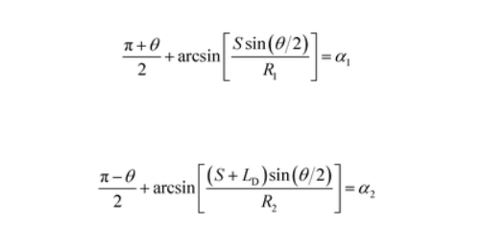

These two equations are geometric structure equation

Were,

0 = non-parallel plates

Theta = angle between non-parallel plates

ld. = droplet of length

S = distance between droplet of cusp

R1 and R2 = radius of curvature right and left

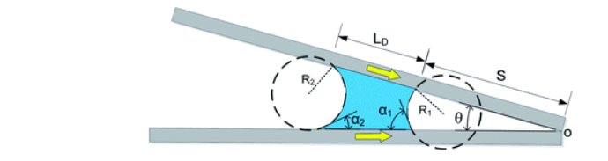

**Figure 3.2 liquid bridge between two spheres**

The case of inward motion it is transformed into the equation are –

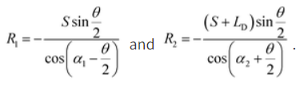

The equation of Laplace in the inward motion that make satisfy the alpha 1 = alpha 2 and alpha 2 = alpha 2. The angle of advancing droplets respectively. The requirements it is found by



The equation of inward motion in the presence of

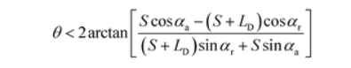

The equation of pi / 2 and pi / theta is satisfied in two reasons

A = in the liquid bridges will be hydrophobic in the surface simultaneously

B = very small theta is approaching across decreasing in the ld. /s. the motion of the liquid bridges completely as the non - parallel equation.

After the all equation is write successfully like

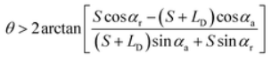this is the equation of outward of liquid bridges. And the other equation of the liquid bridges.

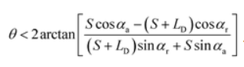

## **3. 5 The surface of two planar between the capillary bridges**

In the parallel surface to use cartesian coordinate system in the parametric equation is describing for meridional profile in the liquid bridges. In these bridges we take a distance between two plane and do analytics calculation.

Let the two surfaces of different materials of liquid bridges for different angle of theta. There are boundary condition in the median of three triple points in the meridian of capillary bridges given by

The cross section of two parallel plates.

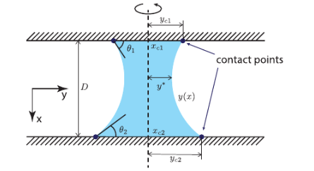

**Figure 3.3 Coordination of contact points**

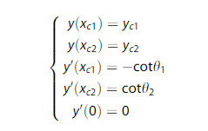

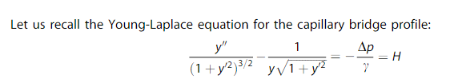

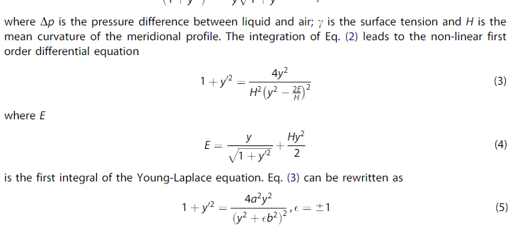

## **3.6** **Two parallel plate in identical materials**

The first section examines capillary connections that connect two similar planes. For each test, we see that the crossover between both the nodded and undulous shapes passes via the specific catenoid shape that corresponds to H140 as the separation distance D increases. As shown in Figure 2, the contact points and the two surfaces are identified, giving adequate details for the numerical model provided to reconstruct the shape of the fluid bridge. In every instance, the numeric curve matches the meridian profile of the capillary bridge exactly. It is clear that the collar radius y exhibits a declining trend as the distances and angles D increases. Figure 3 demonstrates that the mean curve Begins with a particular benefit, that correlates to a piece of the ovoid surface, and then shifts to a minus sign, which relates to the exterior.

## **3.7 Two parallel plate in same materials**

The practical study's second section takes non-symmetrical capillary bridges along the x-axis into account. The neck of the liquid bridge is not situated in the middle of the two planes because two planes made of different materials cause contact angles at the two planes to have different values. A comparable volume of water (V141ll) was injected between the two planes for comparison's sake. Figure 6 depicts the analyses that followed. A strong connection was discovered between both the empirical results and the theoretical curves shown in Results 1 and 2. Teflon, a hydrophilic substance, is used to make the bottom plate, giving it a higher contact angle than glass. It has been demonstrated that the capillary bridge's form is significantly affected by the contact angle. The Young-Laplace equation's solution, however, continues to satisfy the minimum surface principle, resulting in consistency between the results of numerical and experimental methods. The Young-Laplace equation's suggested exact analytical solution has been shown to be accurate for a variety of materials.

## **3.8 liquid bridges of unsaturated porous**

* Detachment of liquid bridges formation

We briefly summarize key findings from our previous work on modelling liquid bridge generation and separation in unsaturated fractures in this paragraph Asperities and other geometrical alterations that are connected to the creation of fluid bridging act as anchors for capillary pinning of a developing liquid bridge   The existence of enough liquid flux directed towards an anchoring location in the crack sustains the periodic process of development and discharging of liquid bridge (either as film or matrix flow).

The geometric model depicted in Figure 1 idealises the environment and process by taking into account a fracture with a homogeneous diameter b that is inclined at an angle of from a flat direction. is a fracture with a homogeneous diameter that is inclined away from a horizontal plane at an angle of? A fluid footbridge is created beneath the blockage by directing a flow rates rate Q in its direction. The method computes the flow velocity (regularity) and mass of the ejected liquid mass as functions of shape, flow rate, and fluid characteristics.

## **3.9 In the two-dimensional liquid bridge**

In 2-d Laplace law surface bounding of liquid in the two flat horizontal substrates written as

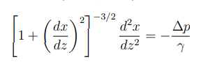……………………………………………………1

Were,

Z = measured height substrate to bottom

X = symmetry of horizontal plane in 2-d bridge

∆p(z) Changes the pressure across the surface bridge to all height

γ= it is liquid of surface tensions

according to equation 1 in there are two surfaces first is bounding the bridge surface other is mirror bridge of ither surface wrt x = 0.

Secondly, we define as inside bridge of pressure we can write the equation of change the pressure inside the bridge



Were,

P1 = pressure inside the bridge

P2 = atmospheric pressure outside the bridge

If the pressure put into the inside and outside bridge there are make a equation of hydrostatic equilibrium

……………………………………….2

Were

P20 is bottom of substrate of pressure inside the bridge

G = gravitational acceleration bridge

Ρ = it is liquid bridge of density inside the bridge.

We can change some variable

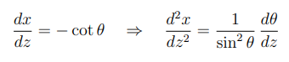………………………...3

The θ it is a bridge of inclination. in the difference of angle and tangent bridge at the surface point at the point (x and z) their horizontal axis is like theta lies between o and pi.

According to equation 1 and 2 as 1 equation as,

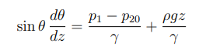…………………………………4

We can be solved by theta in straight forward

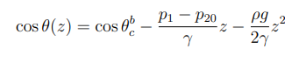………………………………………….5

Where put the value of theta = θ b c , andz = 0 of height h,

θ b c  = the liquid of contact angle in interval of  the integrated of equation 4 like put into the z= 0 and z is equal to h in the right-hand side rule in the explain to pressure like equation 5 where eliminate this term.

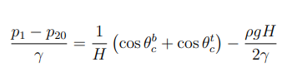………………………………6

When equation 5 in expressed that z, h theta b and c, theta t and c.

….7

Id the equation is more simply by scaling the dimensionless by h , when the difference between the top and bottom of bond number b 0 is like 

This equation of bond number put the value of H. as well as replace z’ = z/H,

We can write an equation

…….8

Then function of x is z by the definition of dx/dz then x’ replace by x’ = x/H

Where it is given by

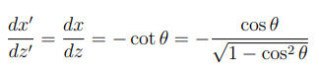…………………….9

As compare of equation of 8 and 9 then written by

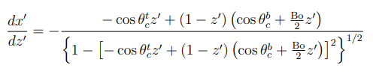

When integrating after put z’ = 0

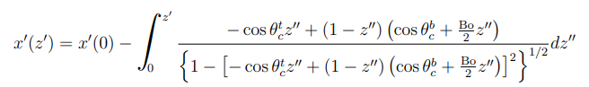….11

In the shape of equation, the surface of right-hand side in between the bounding a bridge of z’ = 0 and top to z’=1 where it is a zero gravity then b0 = 0

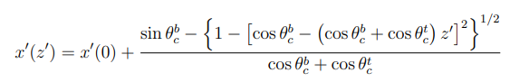…….12

We can used cross sectional area of liquid bridge as

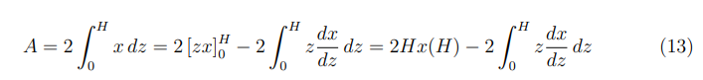

We can used to second quality of integrating by parts for the factor like 2 equations in the symmetric filed of x = 0 at the dimensionless surface of x = 0 and a a’ = a/h

………………….14

According the equation of 10 and 14 as

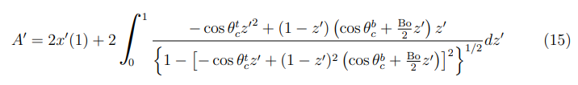

Z is equal to h we locate this position and surface of bridge in vertical there are concave surface bridge the differential between of x and z is greater than 0 and the convex surface x and z are less then 0 like

Concave surface = 

Convex surface = 

When this is followed from cos theta = z = h = 0

The units of h’ = h/H

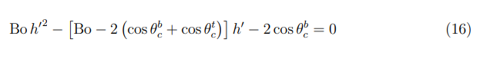

We can solve the equation of straight forward like h’

In this equation thetre are n

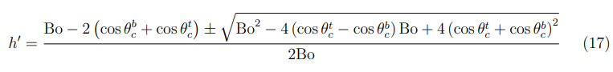

In this equation there are no real value and no real root where it is range of h’ lies between 0 and 1 in the gravity of zero is like b0 = 0

In the equation of the h ‘is like

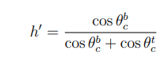……………………………………18

After this equation is solved like the addition of the contact at the angle between the substrate at the theta b and c, theta t and c where h are like h = h / H

Were h = ½ - …….19

All this solution is that is physical into the h lies between the 0 and 1. In the presence of the gravity is like no reflection point. in the inflection; point will be at the end of half bridge and full bridge at the bottom of the total amount of liquid bridge

* If the bridge is single neck at the point is corresponding of the equation of h lies between h’ and 1 where x is the function of the 0 and h’ is the function of the h
* In this bridge the minimum cross-sectional area of two bonding as the touch of surface area. And this two-surface touch in the liquid field at the part of the distance h is given by theta b and c, theta c and t.

## **3.10 Method of numerical**

The porous zone is effect by capillary bridge in the models of numerical scheme. The range of porous media is given by obstacles in the process of porous structure. We have calculated by the flow of multi-phase in Hilliard equation

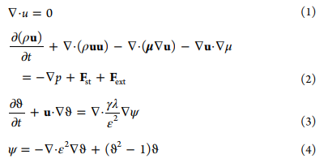

The order of equation in the face of body

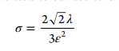

The tension o surface area in the field of fs



So interface roughness and velocity are three crucial elements in the phase field model. Generally, a significantly finer screen is needed for a smaller interface height. Resulting in a significant rise in computing expense and producing issues with the cohesive zone product's culmination because although it will have a responsiveness and be very closer to the answer. presumption. Consequently, the significance of must be connected to it the suggested mesh size is half of the present mesh size. greatest size distribution. With respect to any specific significance of, the friction coefficient expression and mixture energy content may be acquired using eq 5. Determined by the movement variable the Clausius diffusion's temporal horizon, and it consequently controls the network adapter gradient timeframe.

We have shown a graph of variable time

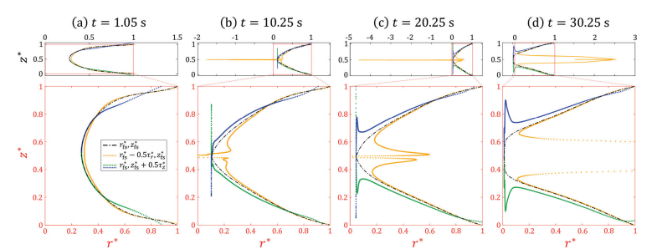

**Figure 3.4 Graph of variable time**

In this figure we show that two liquid bridges in the time 1.05sec, 10.25. this is similar to the sharper in the case of developed field is like further in the together as the tc in the free liquid bridges. That is observed in the positive case of compressive in the distribution path.

## **CHAPTER 4**

## **EXPERIMENTAL AND RESULT**

In equation 11 and 15 result of all value of B0, theta b and c, theta t and c is their non – trivial condition

N the equation 8 the all-meaningful solution can exist if the cod theta lies between -1 to 1 then equation is

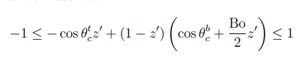

The equation 20 the lower and upper bond is their integral of every value of z’ in difference of 1 and 0 and the equation of 8 like cos theta. In the equation 20 in automatically satisfy in their z’ = 0 and z’ = 1 by extracted of solution. In the equation 20 can be hold because bond number is greater and equal to 2 like we show a equation



In this is the inflection point of condition of the remarking bridge surface equation 19 that give us by h’ lies between the 0 and 1

Let inequality of left-handed in the alternative by show as: -



It will we solved like

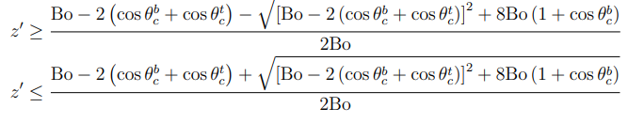

In these two above equations that expressed by the roots of non – negative is always true. In this calculation we have right-handed side of second inequality for all 0 and it satisfied by all z and b0

In this equation we turn into the bond number like

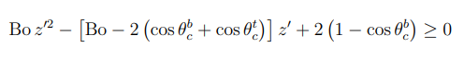

We are writing two equations in the z is greater than the all variable

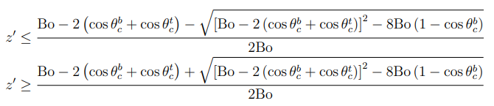

In this equation we can square both side and ignore non - negative value after the equation will be changed.

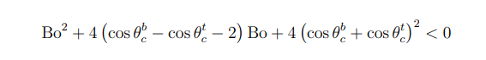

As the value will be hold can be equation is like: -

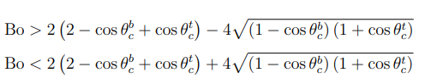

In the equation of square like it is clearly that non – negative calculation is explicit like

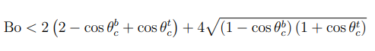

Remembering the meaning of Bo, this indicates that there really is a maximal platform spacing above which a flowing bridge could cover the distance between any two substrates: the bridge falls under its own burden. 4 capillaries length are the theoretical highest spread for a fluid bridge. is reached when the Bond number appears upper limit is at its highest, the value of b0 = 16 and θ b c = 1800 and θ t c it is separation between the substrate in form of bridge and the upper bond number is 0. it is the condition of upper bond and the bridge surface is vertical. The equation of square root is non-negative it is lies between h’ is o and 1.

## **4.1 Perform force calculations for systems of increasing geometrical complexity**

**a- The porous structure of modelling in flow condition**

The hydrodynamic characteristics of the solvent combination are maintained in all numerical scenarios of this study since we are primarily interested in the impact of the high porosity on liquid retention, while the pore shape and hydrophilicity are varied. Figure 2 depicts a layout of the current numerical model. Our simulation takes place on a symmetrical 2D domain with a porous zone that is initially dry. A solid plane is pushed vertically while a liquid droplet with an initial radius of 5 mm is put upon it. To ensure that the droplets reaches the porous tip as well as the fluid bridges forms here between solid and porosity surfaces, the firm plane is raised by a predetermined amount (1 mm).

## **4.2 Result of simulation**

The behaviours of a liquid footbridge are studied using the suggested mathematical method under various circumstances and geometries. According to Figure 2, after coming into contact with the amorphous tip, the droplet is propelled by capillarity to invade the highly permeable zone, and the evident contact angle just outside of the tip rises along the ambiguous side with the inside fluid front establishing in a liquid bridge. However, when the strong plane is pulled far from the porous tip, the contact line slips on the porous and manages to pinch while the liquid imbibes. Part of the outside water persists on the tip when the fluid bridges disintegrate, while the remaining portion is still affixed to the aircraft.

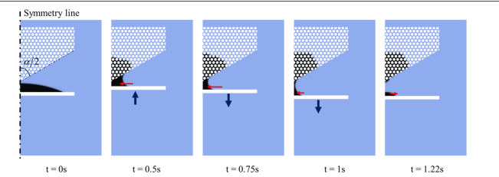

**Figure 4.1 amorphous liquid of surface**

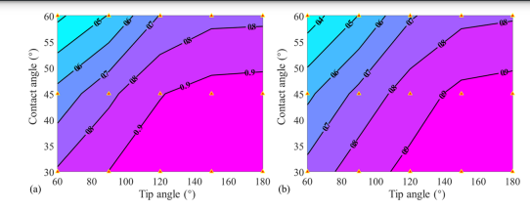

**Figure 4.2 Graph of angle surface**

## **4.3 Another method of Geometric model of derivative process**

Another method we use in this report with he helps for capillary bridge between two solid we know that in two adjacent solid is formed by inviscid in fluid bridge in the case of curvature in governed by Laplace equation is easily corresponding by the liquid. We use a two-sphere plate in two dimensional cartesian system of oxy this is denoted by x and neck into the liquid bridges.

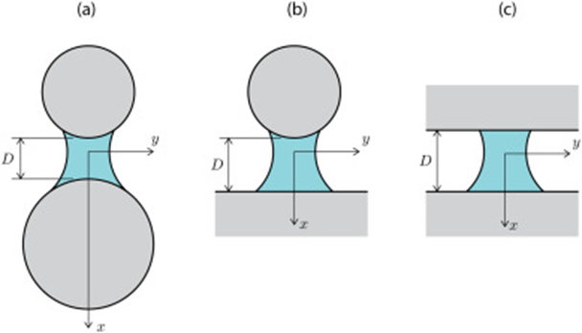

**Figure 4.3 derivative process**

We show three images in above figure with coordinate x and y axis. It is surface of revolution of curvature h in capillary bridge as the equation written as

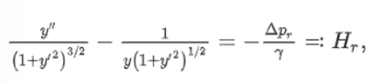

Where the difference between air phase and liquid phase in the surface tension is x tends to y in the upper profile, we use in these calculations in young Laplace equation and we take a differential equation

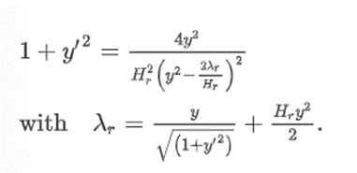

In these two equations we use node of e = 1 and we take two parameters in geometrical data we will discuss the liquid bridge in sub section.

According two young’s Laplace equation we are take two same parallel planes in capillaries bridge and neglect the gravity of surface tension and coordination between change of angle theta.

We are show two parallel images

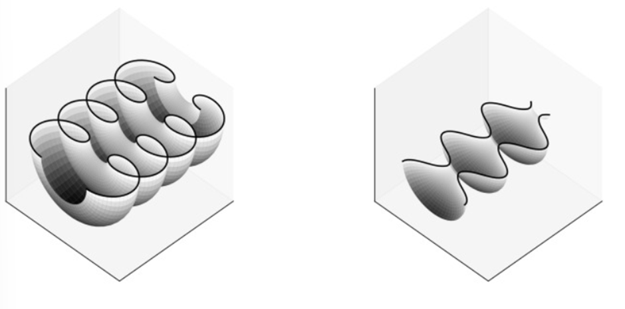

**Figure 4.4 parallel image**

## **4.4 Capillary force calculation**

In the general parameter of separation of size in the volume of liquid bridge in the case of solid particle this is angle pf wetting they between the solid particle calculated by set pf condition is standard sign, in the negative forces denote by repulsiveness. There are forces acting that make up the total forces. These are the interfacial tension in term of the perpendicular of the droplet it means the sold surface it own part in the range of coordinate axis has the value is same.



Where gamma is a surface tension In the first example, the wetting force is attractive (hence the negative sign), but as will be discussed later, a repulsive character can also be found depending on the meniscus geometry. The second force comes from capillary pressure, Δ pressure difference across curved air liquid interface definable by the well-known LaPlace Young equation calculated over the axially projected wet area of ​​each particle:

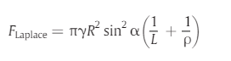

These two equations are called capillary force between l and p

## **4.5 Description method of experiment**

The method of experiment follows by two method first is deposition process and second is measure of rate flow we show you both process though figure

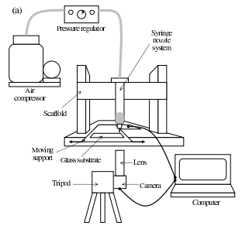

**Figure 4.5 trasnent simulation**

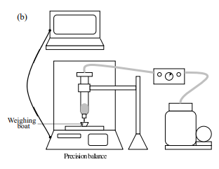

**Figure 4.6 distortion process**

In the first step fluid is working in the inner nozzle and it round between two processes through turbine constant value in linear set into the motor stage to plate-form it is vertical download and vertical upward. the deposition line transfer into the stage of regulation system. It is the obtain the picture approximately difference of substrate speed due to injection velocity. In this velocity are slow down the speed but is depend on the controlled volume reason of velocity. In this experiment the mass flow is calculated by leads of average speed in pressure compressed of mass flow. The flow after one minute the regulation speed is fast at the time. In this work is very useful to range if fluid power supply. Sometime speed is going to twice and minute by minute time is variable to whole system.

## **4.6 Result of these two experiments**

This is the application between two threads into the sub- particle it is identify the maximum dimensions of local surface area into the free surface. At the point it makes into the small step solution. The mesh point is involving in the single time there are follow two types of simulation.

A – transient simulation

B – distortion of repeated solution

We have compared these two types of solution and show a graph.

Figure 4.5 shows that the pressure regulator is regulate the air compressor and connect with syringe nozzle system after this process has been done that’s why lens and camera are tipped into the surface. The surface plate is smoothly removing a particle and all the process are show in computer system. As well as figure 4.6 are monitor the distortion process and weighted the regular supply into their path that’s do in as less time interval.

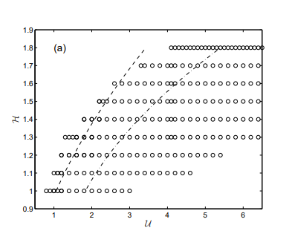

**Figure 4.7 transient solution**

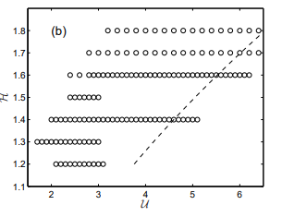

**Figure 4.8 distortion solution**

# **CONCLUSION**

In this project firstly we will integrate theorem of young modules in 2-dimensional bridge. we are finding a difference between two plate and other we find difference between two spheres. This extrapolates our prior research, which presupposed that what a fluid sheet of zero thickness joined the meniscus tears at the two surfaces. We've determined the variety of separation widths for specified angles there at apex where the liquid bridge can exist and materials at the bottom. Additionally, we had calculated the smallest bridge size of another given circumstances that would allow any heads or protruding to develop and their location in the fluid bridge or ridges or indentations on its surface. It is feasible that some of these 2D forms could might out be unsteady in relation to, for instance, a sequence of spaced evenly axially symmetric structures parallel to the 2D bridge's axis in axis y. We seem unable to address this problem at this time since doing so would need a more thorough investigation. Maybe the biggest flaw in our strategy is that, in addition to presuming a 2-dimensional shape, we ignored the frictional forces force, or the direct contact between the linking process edges. This has been the focus of several experiments conducted and is recognised as being important in the limit of thin bridges [44]. Nevertheless, the exact simulation of the Young-Laplace equation with frictional forces relevant searches must wait till a future release. In the future we calculate the energy. We use a mathematical model and Utilizing fluids with various viscosities, the impacts of rate on the fluid bridges were further investigated. An percentage on forceful displaced connection phenomena has been introduced with a rise in measuring and control: The elongation increases with the found this to be true. whilst experiencing an decompression phase decrease. In addition, the percentage on Resistivity of the friction coefficient has indeed been noted: Less retreating is caused by faster movement. inclinations in the operation of expansion and bigger advanced angles in the compaction process. Dynamical Both explain and forecast that findings of the experiments that have been conducted, models are developed. The actual contact point A loop framework has indeed been suggested using resulting in the emergence theories. & Young's formula That method is able to forecast the dynamically advance degree at varying paces and imitate the lowering of the recede degree. Additionally, a dynamical model has been developed to forecast how the fluid bridges would deform in a changing situation. These findings show that now the fluid model and experimental findings accord well.

Its impact of fluid dynamics on the fluid bridge is not taken into account by this modelling process. As a result, additional modifications of the existing diagnostic process is defined. This link between its velocity of the contact area and the velocity of the sliding plates has still not been researched. What a connection may connect the contact point speeds and the cohesion and friction angle. As both a consequence, it is able to ascertain the dynamic contact angle vs relative permeability, which depends on viscous, connector velocity, and surface energy. Research have been made on the characteristics of the fluid bridges across different surfaces. The interfacial tension repeatability exhibits steady advancing and retreating angles whenever a fluid bridge develops across two hard aluminium sheets after cleaning, SMAT, and sand blasting with 30 meters glass beads. However, the contact angle hysteresis for the aluminium plates subjected to sandblasted with glass particles of 50 m also isn't clearly depicted. It is possible to determine the capillary force and the contact angle hysteresis when a fluid bridge develops across two equal spherical. Additionally, the analytical model was developed to compute the capillaries pressure to characterise the interfacial tension or filled degree repeatability. Its model accurately and empirical studies are in excellent accordance when examined. There is a ratio between the maximum and bottom interfacial tension persistence when a fluid bridges forms among a spherical but a plate. Additionally, there are differences mostly in dislocation at every step of a expansion and compressive processes. Further research is required on how surface roughness affects the droplet contact angle as well as the contact angle hysteresis in these extensive tests. A cause of this occurrence should be explained as the contact angle hysteresis on the surface decreases while being treated with plastic beads that are 50 m in diameter. Our research confirms that the impact of foam on the water phase's mobility in porous media is minimal and may be disregarded. Its incorrect design of the silane roughly comparable contours is blamed for the inconsistent results in the literature. The soluble step diffusion coefficient in the appearance of foam generally relies on the ionic strength for the processes used here study when the stable data on fuel permittivity (assessed at low blood capillaries numbers) is being used. In specific, the evident indefinable water saturation (Swc) reduces as the surfactant concentrations increase. However, the impact on foamy on the motility of the water form is negligible whenever the absorption coefficient is assessed at high drainage values. Fluid bridging development can facilitate oil outflow in organically hydraulic fracturing, create capillaries consistency among porosity lattice, and alter contamination movement in igneous and metamorphic rocks. A mathematical formulation of the static presence of soluble bridge was reported in this research. The geometry of the fluid bridging surfaces may be expressed as follows of and as specified non - dimensional variables in this novel non - dimensional solution of the Young-Laplace equation. An equation characterising a fuel contact for one limited situation of microgravity. Simulated using computational methods offer a quick and effective way to investigate the behaviour and architecture of complicated things. Solutions can constantly be confirmed by contrasting their output with experimental findings since its correctness and dependability dependent just on calibre of both the protective shield used to describe the biomolecules contacts. One of the finest methods for carrying out this procedure is proton bouncing since the observed measurements (static analysis overall system performance) and also the sampling time and length scales closely match the values that may be calculated from a Molecular dynamic. Models using computational methods offer a quick and effective way to investigate the behaviour and composition of complicated things. As just a result, the primary result of a model is a piecewise path, and the academic task is to use the precise data on the locations, velocity, etc pressures of the atoms to derive crucial data well about mechanics of sample under test. Since a percentage of straightforward, consumer software platforms and trustworthy force fields have been developed over the past fifty years, quantum physicists can now simply avail computational models, which are progressively being a necessary tool for analysing but also interpreting challenging experimentations completing. When isolated fluid components are compared to their continuous sheet flowing counterparts, there is a significant difference in the quick travel velocities and greater lengths that they can cover. In proper waste plans and assessments for groundwater, the effects of these kind of modes that have the capacity to concentrate diffuse liquid films into swiftly moving discontinuous liquids spans should be taken account. When addressing a community of fluid bridging inside a fault surface and mass buildup at fracture junctions, these stream concentrating mechanisms may well be intensified. The findings offer a practical framework for addressing and maybe measuring complicated and interrupted fluid flow seen in field and lab research. limitations relating to interactions inside fractures, inner break morphology and surface qualities, as well as other constraints

# **REFERENCES**

Aspenes E., Ersland G., Graue A., Stevens J., Baldwin B.A. (2008). Wetting phase bridges establish capillary continuity across open fractures and increase oil recovery in mixed-wet fractured chalk. Transport in Porous Media, 74, 35-47.

Dejam M., Hassanzadeh H. (2011). Formation of liquid bridges between porous matrix blocks. AIChE Journal, 57, 286-298.  Dejam M., Ghazanfari M.H., Kamyab M., Masihi M. (2011). The gas-oil gravity drainage model in a single matrix block: a new relationship between relative permeability and capillary pressure functions. Journal of Porous Media, 14, 709-720.

Ghezzehei T.A., Or D. (2005). Liquid fragmentation and intermittent flow regimes in unsaturated fractured porous media. Water Resources Research, 41, W12406.

Or D., Ghezzehei T.A. (2007). Traveling liquid bridges in unsaturated fractured porous media. Transport in Porous Media, 68, 129-151.

Gat A.D., Navaz H.K., Gharib M. (2012). Wicking of a liquid bridge connected to a moving porous surface. Journal of Fluid Mechanics, 703, 315-325.

Navaz H., Zand A., Atkinson T., Gat A.D., Nowakowski A., Paikoff S. (2014). Contact dynamic modeling of a liquid droplet between two approaching porous materials. AIChE Journal, 60, 2346-2353.

Saidi A.M. (1987). "Reservoir Engineering of Fractured Reservoirs-Fundamentals and Practical Aspects", Total Edition Press.

Horie T., Firoozabadi A., Ishimoto K. (1990). Laboratory studies of capillary interaction in fracture/matrix systems. SPE Reservoir Engineering, 5, 353-360.

Firoozabadi A., Markeset T. (1995). Laboratory studies in fractured porous media. Part I. Reinfiltration for gas-liquid systems. In Situ, 19, 1-21.

Labastie A. (1990). Capillary continuity between blocks of a fractured reservoir. SPE 20515, "Proceeding of SPE Annual Technical Conference and Exhibition", New Orleans, Louisiana, Sep. 23-26.

Stones E.J., Zimmerman S.A., Chien C.V., Marsden S.S. (1992). The effect of capillary connectivity across horizontal fractures on gravity drainage from porous media. SPE 24920, "Proceeding of 67th Annual Technical Conference and Exhibition of the Society of Petroleum Engineers", Washington, DC, Oct. 4-7

Firoozabadi A., Markeset T. (1994). An experimental study of the gas-liquid transmissibility in fractured porous media. SPE Reservoir Evaluation and Engineering, 9, 201-207.

Sajjadian V.A., Danesh A., Tehrani D.H. (1998). Laboratory studies of gravity drainage mechanism in fractured carbonate reservoir-capillary

continuity. SPE 49497, "Proceeding of International Petroleum Exhibition and Conference", Abu Dhabi, United Arab Emirates, Nov. 11-14.

Dejam M., Ghazanfari M.H., Masihi M. (2009). Theoretical modeling of reinfiltration process in naturally fractured reservoirs: a comparative study on traveling liquid bridges and continuum film flow approaches. SPE 125307, "Proceeding of SPE/EAGE Reservoir Characterization and Simulation Conference", Abu Dhabi, United Arab Emirates, Oct. 19-21.

S.-J. Hong, F.-M. Chang, T.-H. Chou, S. H. Chan, Y.-J. Sheng, and H.-K. Tsao, "Anomalous contact angle hysteresis of a captive bubble: advancing contact line pinning," Langmuir, vol. 27, pp. 6890-6896, 2011.

L. Gao and T. J. McCarthy, "Contact angle hysteresis explained," Langmuir, vol. 22, pp. 6234-6237, 2006.

A. Akbari, R. J. Hill, and T. G. van de Ven, "Liquid-bridge breakup in contact-drop dispensing: Liquid-bridge stability with a free contact line," Physical Review E, vol. 92, p 022404, 2015.

J. Van Honschoten, N. Tas, and M. Elwenspoek, "The profile of a capillary liquid bridge between solid surfaces," American Journal of Physics, vol. 78, pp. 277-286, 2010.

M. Fortes, "Axisymmetric liquid bridges between parallel plates," Journal of Colloid and Interface Science, vol. 88, pp. 338-352, 1982.

J. Israelachvili, "Intermolecular and Surface Forces (; London," ed: Academic Press, 1992.

[ Y. I. Rabinovich, J. J. Adler, M. S. Esayanur, A. Ata, R. K. Singh, and B. M. Moudgil, "Capillary forces between surfaces with nanoscale roughness," Advances in colloid and interface science, vol. 96, pp. 213-230, 2002.

[C. Gao, P. Dai, A. Homola, and J. Weiss, "Meniscus forces and profiles: theory and its applications to liquid-mediated interfaces," Journal of tribology, vol. 120, pp. 358-368,1998.

R. Fairbrother and S. Simons, "The rapture energy of liquid bridges between sphere; the effect of contact angle and separation distance on liquid bridge geometries," 1998.

M. Matthewson, "Adhesion of spheres by thin liquid films," Philosophical Magazine A, vol. 57, pp. 207-216, 1988.

B. J. Ennis, J. Li, and P. Robert, "The influence of viscosity on the strength of an axially strained pendular liquid bridge," Chemical Engineering Science, vol. 45, pp. 3071-3088,1990.

X. Zhang, R. Padgett, and O. Basaran, "Nonlinear deformation and breakup of stretching liquid bridges," Journal of Fluid Mechanics, vol. 329, pp. 207-246, 1996.

A. M. Davis and A. L. Frenkel, "Cylindrical liquid bridges squeezed between parallel plates: exact Stokes flow solutions and hydrodynamic forces," Physics of Fluids A: Fluid Dynamics (1989-1993), vol. 4, pp. 1105-1109, 1992.

W. Barthlott and C. Neinhuis, "Purity of the sacred lotus, or escape from contamination in biological surfaces," Planta, vol. 202, pp. 1-8, 1997.

[89] B. He, J. Lee, and N. A. Patankar, "Contact angle hysteresis on rough hydrophobic

surfaces," Colloids and Surfaces A: Physicochemical and Engineering Aspects, vol. 248, pp. 101-104, 2004.

M. Paajanen, J. Katainen, O. H. Pakarinen, A. S. Foster, and J. Lahtinen, "Experimental humidity dependency of small particle adhesion on silica and titania," Journal of colloid and interface science, vol. 304, pp. 518-523, 2006.

M. Farshchi-Tabrizi, M. Kappl, Y. Cheng, J. Gutmann, and H.-J. Butt, "On the adhesion between fine particles and nanocontacts: an atomic force microscope study," Langmuir, vol. 22, pp. 2171-2184, 2006.

D. Wu, N. Fang, C. Sun, and X. Zhang, "Stiction problems in releasing of 3D microstructures and its solution," Sensors and Actuators A: Physical, vol. 128, pp. 109- 115, 2006. C. H. Mastrangelo and C. Hsu, "Mechanical stability and adhesion of microstructures under capillary forces. I. Basic theory," Journal of Microelectromechanical systems, vol. 2, pp. 33-43, 1993.

W. Thomson, "4. On the Equilibrium of Vapour at a Curved Surface of Liquid," Proceedings of the Royal Society of Edinburgh, vol. 7, pp. 63-68, 1872.

R. Price, P. Young, S. Edge, and J. Staniforth, "The influence of relative humidity on particulate interactions in carrier-based dry powder inhaler formulations," International journal of pharmaceutics, vol. 246, pp. 47-59, 2002.

[ J. Qian and H. Gao, "Scaling effects of wet adhesion in biological attachment systems," Acta Biomaterialia, vol. 2, pp. 51-58, 2006.

N. Stork, "Experimental analysis of adhesion of Chrysolina polita (Chrysomelidae:

Coleoptera) on a variety of surfaces," Journal of Experimental Biology, vol. 88, pp. 91- 108, 1980.

G. Walker, "Adhesion to smooth surfaces by insects—a review," International Journal of Adhesion and Adhesives, vol. 13, pp. 3-7, 1993.

K. Autumn, M. Sitti, Y. A. Liang, A. M. Peattie, W. R. Hansen, S. Sponberg, et al.,"Evidence for van der Waals adhesion in gecko setae," Proceedings of the National Academy of Sciences, vol. 99, pp. 12252-12256, 2002.

T. Eisner and D. J. Aneshansley, "Defense by foot adhesion in a beetle (Hemisphaerota cyanea)," Proceedings of the National Academy of Sciences, vol. 97, pp. 6568-6573, 2000.

W. Federle, W. Baumgartner, and B. Hölldobler, "Biomechanics of ant adhesive pads: frictional forces are rate-and temperature-dependent," Journal of Experimental Biology, vol. 207, pp. 67-74, 2004.

A. Lees and J. Hardie, "The organs of adhesion in the aphid Megoura viciae," Journal of Experimental Biology, vol. 136, pp. 209-228, 1988.

G. Walker, A. Yulf, and J. Ratcliffe, "The adhesive organ of the blowfly, Calliphora

vomitoria: a functional approach (Diptera: Calliphoridae)," Journal of Zoology, vol. 205, pp. 297-307, 1985.

S. B. EMERSON and D. DIEHL, "Toe pad morphology and mechanisms of sticking in frogs," Biological Journal of the Linnean Society, vol. 13, pp. 199-216, 1980.

T. Ba-Omar, J. Downie, and W. Barnes, "Development of adhesive toe-pads in the treefrog (Phyllomedusa trinitatis)," Journal of Zoology, vol. 250, pp. 267-282, 2000.

Y. Yuan and T. R. Lee, "Contact angle and wetting properties," in Surface science techniques, ed: Springer, 2013, pp. 3-34.

C. Extrand, "Contact angles and hysteresis on surfaces with chemically heterogeneous islands," Langmuir, vol. 19, pp. 3793-3796, 2003.

N. K. Adam and G. Jessop, "CCL. —Angles of contact and polarity of solid surfaces," Journal of the Chemical Society, Transactions, vol. 127, pp. 1863-1868, 1925.

C. Timmons and W. Zisman, "The effect of liquid structure on contact angle hysteresis," Journal of Colloid and Interface Science, vol. 22, pp. 165-171, 1966. E. Bormashenko, Y. Bormashenko, G. Whyman, R. Pogreb, A. Musin, R. Jager, et al.,

"Contact angle hysteresis on polymer substrates established with various experimental 104

techniques, its interpretation, and quantitative characterization," Langmuir, vol. 24, pp.

4020-4025, 2008.

Y. Gan, F. Maggi, G. Buscarnera, and I. Einav, "A particle-water based model for water

retention hysteresis," arXiv preprint arXiv:1307.5372, 2013.

S. Edwards and D. Grinev, "Granular materials: towards the statistical mechanics of jammed configurations," Advances in Physics, vol. 51, pp. 1669-1684, 2002.

R. Behringer, H. Jaeger, and S. Nagel, "Introduction to the focus issue on granular materials," Chaos: An Interdisciplinary Journal of Nonlinear Science, vol. 9, pp. 509-510, 1999.

T. C. Halsey and A. J. Levine, "How sandcastles fall," Physical Review Letters, vol. 80, p. 3141, 1998.

Z. Fournier, D. Geromichalos, S. Herminghaus, M. Kohonen, F. Mugele, M. Scheel, et al., "Mechanical properties of wet granular materials," Journal of Physics: Condensed Matter,

vol. 17, p. S477, 2005.

P. Pierrat and H. S. Caram, "Tensile strength of wet granula materials," Powder Technology, vol. 91, pp. 83-93, 1997.

P. Tegzes, T. Vicsek, and P. Schiffer, "Development of correlations in the dynamics of wet granular avalanches," Physical Review E, vol. 67, p. 051303, 2003.

A. Samadani and A. Kudrolli, "Angle of repose and segregation in cohesive granular matter," Physical Review E, vol. 64, p. 051301, 2001.

S. M. Iveson, J. D. Litster, K. Hapgood, and B. J. Ennis, "Nucleation, growth and breakage

phenomena in agitated wet granulation processes: a review," Powder technology, vol. 117, pp. 3-39, 2001.

D. Geromichalos, M. M. Kohonen, F. Mugele, and S. Herminghaus, "Mixing and condensation in a wet granular medium," Physical review letters, vol. 90, p. 168702, 2003.

O. Pitois, P. Moucheront, and X. Chateau, "Rupture energy of a pendular liquid bridge," The European Physical Journal B-Condensed Matter and Complex Systems, vol. 23, pp. 79-86, 2001.

S. M. Iveson, J. A. Beathe, and N. W. Page, "The dynamic strength of partially saturated powder compacts: the effect of liquid properties," Powder Technology, vol. 127, pp. 149- 161, 2002.

J.-B. Valsamis, M. Mastrangeli, and P. Lambert, "Vertical excitation of axisymmetric liquid bridges," European Journal of Mechanics-B/Fluids, vol. 38, pp. 47-57, 2013.

A. Chau, S. Régnier, A. Delchambre, and P. Lambert, "Theoretical and experimental study of the influence of AFM tip geometry and orientation on capillary force," Journal of adhesion science and technology, vol. 24, pp. 2499-2510, 2010.